A Timeline of the Steubenville Rape Case
**Warning: Graphic descriptions, images, and language ahead.**
Much of this story and more can be found here: http://www.dailykos.com/story/2013/01/03/1176096/-The-Steubenville-Gang-Rape-A-Timeline
It was August 11th when an end-of-year celebration occurred in Steubenville, Ohio. The end of summer brought students from a number of nearby schools for a party that would end some of their high school careers, while others celebrated before the new semester began. What was intended to be a wild night of fun and underage drinking, but it quickly turned into something much darker.
On that night, one young woman was brutally violated. Her body was still, carried by her feet and hands. Word quickly spread of the night’s insidious turn. The evidence? A trail of twitter posts, Youtube videos and Instagram photos painted a picture of rape. The young woman in question was from Weirton, West Virginia, not too far from Steubenville. Much of the evidence magically vanished, but some remained. When all the evidence was considered, it seemed the young woman had gone unconscious, then was sexually violated in a number of ways, included being urinated on and forcefully penetrated. At the end of the night she was deposited on the front steps of her parents’ home.
On August 22nd, Trent Mays and Ma’lik Richmond were arrested for the rape in question. Police accused the pair of carrying her between parties and violating her while she was in a state incapable of resisting.
The aftermath is nearly as tragic as the incident itself. The country prosecutor and judge charged with handling juvenile cases stepped away from the case. In a town as small as Steubenville, it is not unusual to hear they had close ties with the football team that Mays and Richmond belonged to. Though the sheriff asked for witnesses to step forward, no one seemed to want to.
Far worse were the active defenses of the football team in question. In a part of the country suffering economic difficulty, football can provide a bright light for a town to rally behind. It can also provide motivation for people to behave in ugly ways. The family in question received death threats for raising the rape accusations. Meanwhile, one Steubenville football coach, Nate Hubbard, said this: “The rape was just an excuse, I think. What else are you going to tell your parents when you come home drunk like that and after a night like that? She had to make up something. Now people are trying to blow up our football program because of it.” The sheriff involved with the case stated to a news crew that witnessing the crime but not reporting it was not illegal. This is false. Failing to report a crime is, itself, a crime.
https://www.youtube.com/watch?v=Ks3bnbAd4II#t=42
With so much resistance to the rape accusations, how did the evidence begin coming to light? It’s related to the town’s resistance against the accusations. It took an online blogger, hacktivist Alexandria Goddard, who accused the town of siding with the rapists, and even accusing the police department of favoritism, to begin moving the wheels of justice. Defamation lawsuits were filed against the Goddard. As of this date, those lawsuits have been dropped, but the point of the resistance remains.
The evidence collected and presented were, in the eyes of law enforcement, not damning enough. This was when KnightSec, a hacktivist collective of Anonymous, stepped in. On January 1st they threatened to come forward with further information if those involved did not take responsibility. When no response came, a 12 minute video of those involved came out, in which one player incriminates himself by repeatedly referencing the girl as both “raped” and “dead”. They make various indications that they knew the girl had been raped. Both the individual on camera, as well as those talking around him, can be heard referencing to her as raped.
*Warning, this particular video is hard to watch. It is the 12 minute leaked video wherein the young men involved in the gang rape talk about their actions. This was originally posted to Youtube, then deleted, then resurfaced through the work of Anonymous.
https://www.youtube.com/verify_controversy?next_url=/watch%3Fv%3DW1oahqCzwcY
The same individual captured in the video posted this to their twitter the night of the incident:
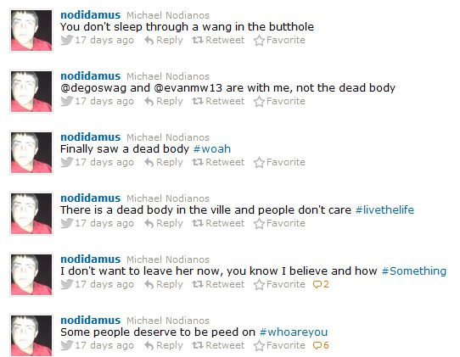
And that a number of people were aware of it, far more than the few who came forward in the case, is made clear by other Tweets collected from that same night:
Prior to much of this evidence, several people involved claimed that they weren't sure it was rape, or that any force was used. Photos taken from the collectivist group produced this:
While Mays and Richmond have been accused, Nodianos' role in the rape case has gone overlooked. Additionally, charges against Cody Saltsman have been dropped. The photo directly above was posted by Saltsman, who claims he received the photo, but was not present at the time of the incident. On the other hand, he responded to Nodianos the night of the rape:
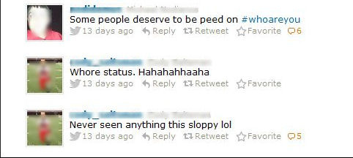
In a country where it seems the protection we afford women is often inconsistent, what's horrifying is that A.) A girl in that condition could be viewed as willing and that B.) People in the two have either refused to come forward or actively tried to suppress the truth of the rape case. Here is one member of the town blaming the victim:
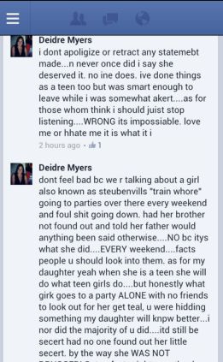
And finally, to reinforce just how miserable members of society can behave, here we have this quote to reinforce how such attitudes are not only isolated, but wider spread than we would like to think. From a poster at deadspin:
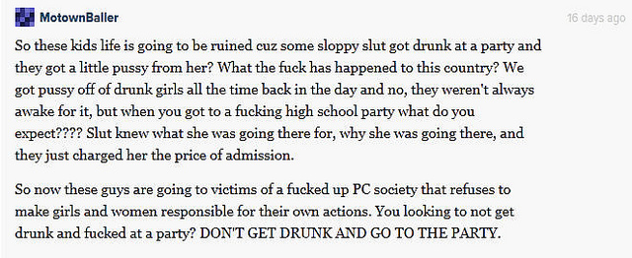
As far as the official legal case is concerned, the Judge put on the case ruled that there was probable cause for rape charges during a hearing on October 12 (almost three months exactly from the date of the allegation). Those testifying included three students who admitted to sending text messages and taking pictures the night of the alleged rape; all three were suspended from extracurricular activities.
On November 1st, the Judge ruled that the defendants would be tried as juveniles, both are released under home arrest.
On December 23rd, Anonymous hacks a fan website for the Steubenville high school football team, Roll Red Roll. They allege a cover-up in the case. A week later, Occupy Steubenville held the first of three rallies in the support of the victim, "Jane Doe".
On January 2nd, the video featured above is released of a former Big Red student, Michael Nodianos, joking about the rape. Several groups call for Nodianos to be charged as well.
In response to allegations from "Anonymous," the City of Steubenville created "SteubenvilleFacts.org". City Manager Cathy Davison says that the website it about being transparent with the facts. Judge Lipps denies a defense motion for a change of venue, January 30.
March 12, a press conference is held before the trial begins. Hancock County Judge Ronald Wilson issues a ruling Tuesday evening allowing three West Virginia juveniles to testify in the Steubenville juvenile rape case.
The complete trial can be read here: http://www.wtrf.com/story/21651380/steubenville-rape-trial-day-one-wrap-up and http://www.wtrf.com/story/21651369/steubenville-rape-trial-day-two-wrap-up. Both articles include some brief testimonies from witnesses.
Trent Mays is convicted and forced to register as a Tier 2 sexual offender. Another hearing is set for Ma’Lik Richmond as the state seeks for a Tier 3 designation for him, “noting the nature of the crime and May’s reported lack of remorse during an assessment.” The trial was futile—Richmond was also forced to register as only a Tier 2 offender. (http://www.wtrf.com/story/23122720/convicted-steubenville-rapist-to-appear-in-court-this-week)
For more information, check out the full Steubenville archive here: http://www.wtrf.com/category/253927/steubenville-ohio-alleged-rape-case-stories-videos

